**Experiment No. 1.2**

**Student Name: Rishav Kumar UID: 22MCC20039**

**Branch: MCA - CCD Section/Group: MCD-1/ Grp A**

**Semester: III Date of Performance: 24th Aug 23**

**Subject Name: Business Analytics Subject Code: 22CAH-703**

1. **Aim/Overview of the practical:**

a) Create a Pivot table to quickly summarize large databases, Group within Pivot Tables.

b) Create multiple Pivot Tables on a single worksheet

1. **Code for practical:**

**A.)**

* Highlight the data range you want to summarize in your Excel worksheet.
* Go to the "Insert" tab in the Excel ribbon, then click on "PivotTable." This will open the "Create PivotTable" dialog.
* In the dialog box, ensure that the "Select a table or range" option is selected and that the correct range is automatically populated. If not, you can manually input the range.
* Choose whether to place the Pivot Table in a new worksheet or an existing one.
* A new worksheet will appear, along with the Pivot Table Field List on the right side of the screen.
* Drag and drop the relevant fields from your dataset into the different sections of the Pivot Table Field List:
* Grouping Within Pivot Table:
* Right-click on a date or numeric field within the Rows or Columns section.
* Choose "Group" from the context menu.
* Define the grouping intervals.

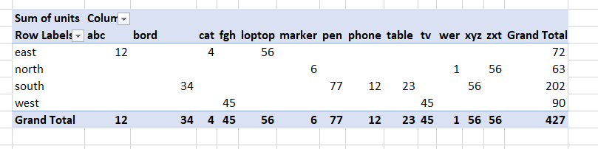

* For the fields placed in the Values section, right-click on them and choose "Value Field Settings" to specify the type of calculation you want

**B.)**

* Highlight the data range you want to summarize in your Excel worksheet.
* Go to the "Insert" tab in the Excel ribbon, then click on "PivotTable." This will open the "Create PivotTable" dialog.
* In the dialog box, ensure that the "Select a table or range" option is selected and that the correct range is automatically populated. If not, you can manually input the range.
* Choose whether to place the Pivot Table in a new worksheet or an existing one.
* In the Pivot Table Field List, select the fields you want to use for your first Pivot Table.
* Instead of dragging the fields to the default areas (Rows, Columns, Values), drag them into specific locations on the worksheet where you want your first Pivot Table to appear.

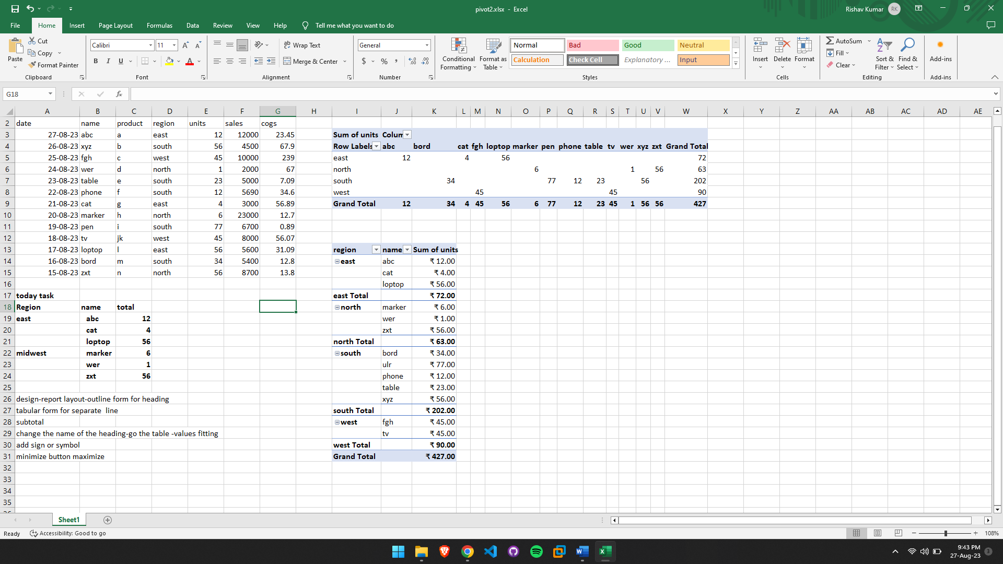

* Repeat steps 1 to 3 for each additional Pivot Table you want to create on the same worksheet. Ensure you use different fields and arrange them differently.
* Arrange, format, and adjust the Pivot Tables as needed to create a coherent layout.

**************************************** **THE END** ***********************************************